Getting Started with the SPARC
Version 1.0 Page 1 of 3
(Students and Placements in ARC) Website
This document describes how to access your student placement allocations through the new practice placements management system, SPARC (Students and Placements in ARC).
For more information about using SPARC, please refer to the SPARC page in the Information section of the Practice Placements website, http://www.practiceplacements.leeds.ac.uk/
- To sign in to the SPARC website, click on the following link,
https://www.sparc.leeds.ac.uk/pep (or type the address into your Web browser). The Sign In page is displayed:
- To sign in for the first time, you will need to click on the Forgot your password? link. The Password Reminder page is displayed:

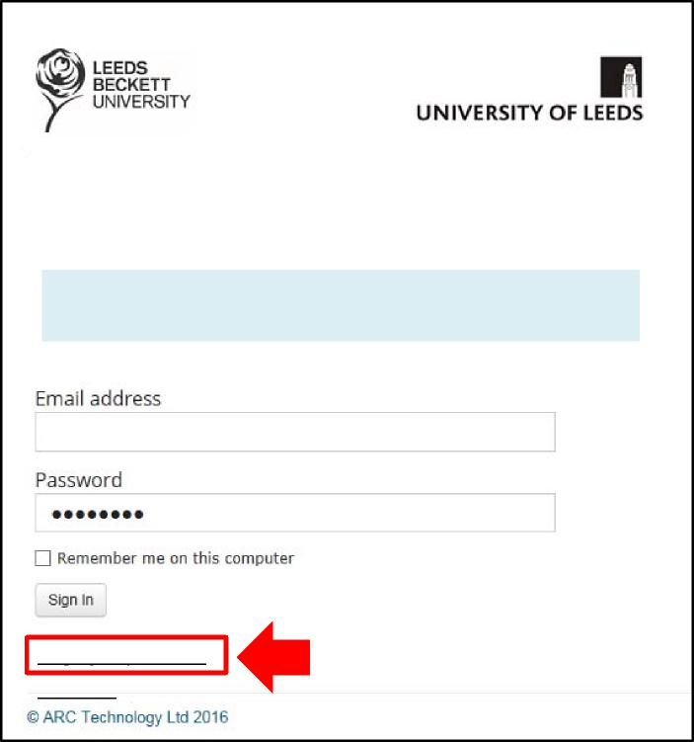
Contact us
Forgot your password?
Welcome to SPARC (Students and Placements in ARC)
To see your student allocations, please sign in with your email address and password.
If you are signing in for the first time, please click the Forgot your password? link below.
A.N.PA@NHS.Net
Getting Started with the SPARC (Students and Placements in ARC) Website

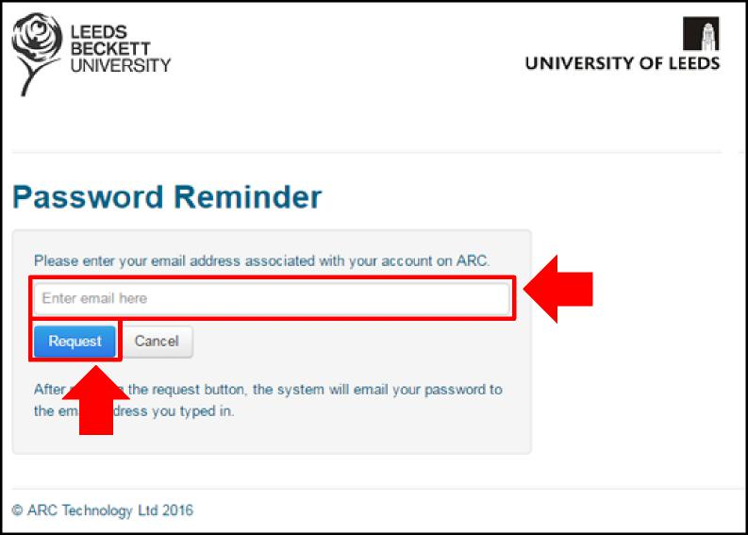
Version 1.0 Page 2 of 3
- Enter your work email address – this should be the email address which has been registered with your SPARC account, and click the Request button.
Note: If you enter an address which has not been registered with SPARC, an error message will appear. You should contact the Practice Placements Unit on 0113 3431375 or email placements@healthcare.leeds.ac.uk for assistance.
- SPARC will send an email containing your temporary password:
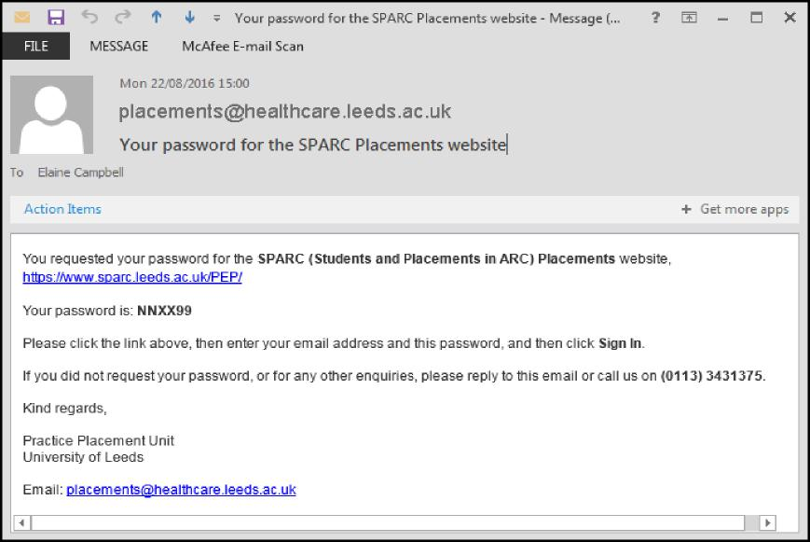
Getting Started with the SPARC (Students and Placements in ARC) Website
Version 2.0 Nov2020 Page 3 of 3
- Return to the Sign in page, https://www.sparc.leeds.ac.uk/pep (see 1 above) and enter your email address and the temporary password in the appropriate boxes.
- Then click the Sign in button; the homepage of your placement area will appear.
Note: Once you have logged in for the first time using the system-generated password, we recommend that you set a new password that will be more memorable to you
- Click the Change your Password button at the top right hand side of the screen and follow the instructions to change your password.
Note: When creating your new password, please note the following information about SPARC passwords:
- they must contain at least 6 characters
- they are case sensitive (so you can use both lower case and CAPITALS)
- they can contain special characters (ie characters other than letters and numbers, eg *)

