PARE Guide for
Practice Supervisors, Practice Assessors
& Practice Educators
Clinical Placements in Leeds
(version 1, 18/08/2021, Leeds’ Clinical Placement Providers)

Firstly, thank you for supporting our learners in Leeds to complete the practical elements of their training.

It is so important that we are able offer high quality learning experiences to our future workforce and with your help we are able to do this.

PARE is instrumental for quality assurance of clinical placements.

This document is designed to support you in using PARE as a Practice Educator/Supervisor/Assessor within a clinical placement in Leeds.

If you have any queries please contact your Practice Learning Facilitators (PLFs):

-Leeds Community Health hayley.ingleson@nhs.net
-Leeds Primary Care leedsprimarycare.wth@nhs.net
-Leeds Teaching Hospitals leedsth-tr.practicelearningfacilitator@nhs.net
-Leeds and York Partnership NHS Foundation Trust pldt.lypft@nhs.net
-All others (Private/Independent/Voluntary organisations and other NHS services) leedsth-tr.pivoplfteam@nhs.net

Contents

Content | Page
PARE - an overview | 3
PARE Practice Educator Guide:
Adapted from PARE Placement Educator Guide, Version 1.1, April 2020, Produced By: Online PARE Team

Adapted from PARE Placement Eductor Guide, Version 1.1, April 2020, Produced By: Online PARE Team
Introduction | 4
Account Activation | 6
My Profile | 7
Making Self Declarations | 8
The PARE dashboard top section | 10
The PARE dashboard bottom section | 12
Notifications | 13
Evaluations | 13
FAQs & Further help | 14
Pebble PAD  (Nursing Practice Assessment Documents) | 18

PARE - an overview

PARE is the online, cloud-based platform accessed by placement areas, students and the universities in Leeds to keep a record of placement and staff profiles, educational audits, capacity and student evaluations.
Each placement has their own profile with useful information for students to access prior to starting placement.
Practice Educators (refers to Practice Educators, Assessors and Supervisors) have individual profiles attached to their placement area where they self-declare their readiness to support/assess students.
Training sessions are advertised and user-guides/videos are available throughout the PARE website. They include information on functions we do not use in Leeds- this guide is specific to PARE functions used in Leeds.
PARE - roles and responsibilities

Practice Supervisors/Assessors/Educators
Once qualified as a Practice Educator/Assessor/Supervisor, the staff with Education Lead/Senior Admin PARE access can grant you an individual profile linked to the placement profile
You are responsible to ensure this is kept up to date.

Make a Self-declaration  (see page 8) | Record the title and date of the training you have undertaken in order to support students
Record Practice Educator updates on your profile (page 8) | This is recommended at least every 3 years  University staff/your PLF will share the means of accessing this with your Education Lead
Ensure your email address is correct | This is essential so that students can share their Practice Assessment Document (PAD) with you
Practice Educator Leads
The Placement Profile is yours to maintain.
You also have an individual profile which requires the actions on the Practice Educator table

PARE user guide link: PARE.Placement.Educator.Lead.Guide.v1.1.pdf (onlinepare.net)

Placement profile | Students access this information prior to attending placement  You can edit this as required
Staff profiles/Educator register  (see page 4) | Once staff have completed their training you need to generate them a PARE account within your placement profile  When staff leave, revoke access/un-assign user from your placement profile
Evaluations | Students are asked to submit evaluations at the end of placement. You need to review these regularly.  Provide feedback to your team as they do not have access to view evaluations.
Educational audit  (see page 14) | Your Liaison Lecturer and PLF will contact you when this is due to be carried out. It is stored on PARE.  Prior to the audit:  -input information into the audit domains  -ensure the staff list is up to date and appropriate levels of access on PARE are granted  -ensure staff are up to date with self-declarations  The Liaison Lecturer/PLF will meet with you to sign off the audit and support in creating action plans where domains have not been met
Introduction What is PARE?
Online Practice Assessment Record and Evaluation (PARE) has been funded by Health Education England (North) since 2013 as both the definitive healthcare practice placement quality monitoring tool, and as a means of shaping information technology integration and development across healthcare practice learning. Designed by a team hosted within the University of Chester, PARE is the result of a substantial collaboration of Northwest universities and healthcare provider organisations.

Core Features of PARE use in Leeds include:
 Multi professional, and cross organisation 'real time' educator registers.
 Generation of real-time multi professional practice capacity, usage, and placement quality metrics.

Online PARE can be accessed from any web browser on any device, via the PARE website address: https://onlinepare.net, which will take you to the PARE Home Page:

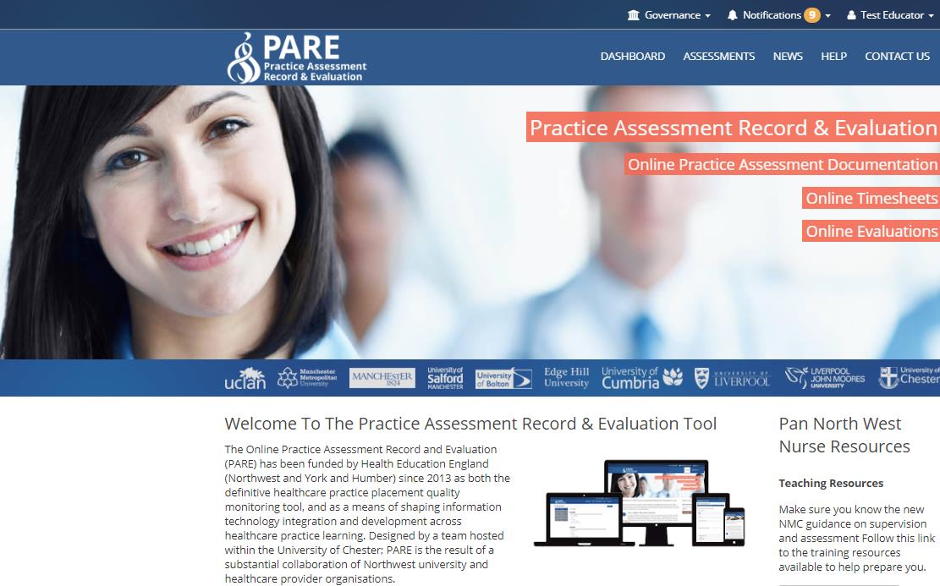

The Purpose of this Guide
The Placement EducatorGuide has been adapted from the PARE user guide to reflect the functions used for Leeds-based placements.
If your profession begins to use the assessment functions of PARE (which is the case for some AHP colleagues in the near future), then you can find the complete user-guide on the PARE website, detailing guidance on the assessment documentation features. This Placement Educator Guide focuses on the features available to PARE users in Leeds who have a Placement Educator PARE account within a placement provider setting. This may be within a Trust or a PIVO (Private, Voluntary or Independent Organisation).
Learners on PARE are usually students from HEIs (Higher Education Institutes, i.e. Universities) including those following an Apprentice route, or increasingly, staff following a preceptorship programme within the placement provider organisation.
A Practice Educator’s role is to liaise with their learners whilst on placement and to work with the learner to complete and sign parts of the learner’s Practice Assessment Documentation (PAD), within the placement educator’s assigned placement area. Nursing Practice Educators in Leeds currently use Pebble PAD to complete online assessment documents, sign-off timesheets and help the learners during their time on placement. Having an up to date PARE profile is necessary in order for students to be able to share their PAD with their Practice Assessor/Supervisor. You will be sent login details to access Pebble PAD.

AHPs use bespoke online platforms for assessments/documentation.

Individuals have different levels of access to PARE depending on their role in supporting students. The PARE accounts available for users in a placement provider setting, and the main features supported for each type of account are:

- Placement Educator (Mentor/Practice Supervisor/Practice Assessor): Practice Educators have an individual profile attached to their placement area. This profile needs to the maintained by the Practice Educator, including making a self-declaration to demonstrate their preparatory training completed in order to support students, in line with their professional bodies requirements.

- Placement Educator Lead (Team Manager): Placement Educator Leads are responsible for one or more placement areas, so have the same access as placement educators, but in addition, have access to manage all user accounts within their placement areas, and access to view the Educator Register. Placement Educator Leads can view learners’ placement evaluation comments and ratings, tag comments and create action plans. In some regions, Placement Education Leads also have access to placement capacity data and audits.

- Placement Educator Support (Student Link): This type of account has the same access on PARE as the Placement Educator Lead, except that a Placement Education Support account does not have access to learner evaluation comments and ratings.

- Placement Senior Admin (PEF): Formerly referred to as a PEF account (Placement Educator Facilitator), the Placement Senior Admin account is the top-level account within a placement provider setting (Trust/PIVO). As well as access to learner’s online documentation for all placement areas within the organisation, the Placement Senior Admin has the same additional access as Placement Educator Leads but for all placements across the organisation, and also has full access to the reporting features on PARE.

For the efficient management of PARE accounts, each PARE placement area should have at least one currently active Placement Educator Lead, and where possible, one or more Placement Senior Admin users. Placement Educator Leads play an essential role, managing the successful use of PARE within their placement areas and monitoring and acting upon learner placement feedback. Placement Senior Admin can do this across an organisation with multiple placement areas, and benefit from the PARE reporting features.

If you currently have a Placement Educator account set up for you on PARE, and are aware that there are no Placement Educator Leads currently active for your placement area, then you may wish to liaise with colleagues to establish a candidate for a PARE account upgrade to a Placement Educator Lead. The Senior Placement Admin for your organisation will be able to do the account upgrade for you, or if unavailable, then please email a written request to the PARE team (see contact details at the end of this Guide). Further PARE User Guides for both Placement Educator Leads and Placement Senior Admin will also provide additional information and support.

Account Activation
Placement Educator Leads/Placement Senior Admin are responsible for managing PARE user accounts on PARE, including the creation of new PARE accounts. If you are not sure if you are registered, you will need to let your Placement Educator Lead/Placement Senior Admin know as soon as possible. When a new account is created on PARE, the system generatesaPARE accountactivation email, which is sent to your PARE account email address. This should be your work email address. It is also advisable to save the PARE website to the favourites on your browser, or as a shortcut on your desktop.

If you have not received the email to activate your account, please let your Placement Educator Lead/Placement Senior Admin know so that they can re-send the activation email to you. It may be necessary to check your spam/junk folder for the account activation email, in case the email is redirected there. If, after several account activation email requests, you have still not received your account activation email, it is advisable to check with your Placement Educator Lead/Placement Senior Admin that your PARE account email ID has been entered correctly on your PARE account (i.e. it is your current work email address and contains no errors). If this is not the issue, then you may need to contact your IT department so that they can check that the www.onlinepare.net domain and the do_not_reply@onlinepare.net email address are correctly whitelisted for your network.

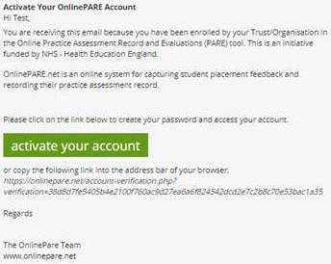
Account Activation Email –
Activation Button/link

When you receive your account activation email, click on the activation link to complete the account activation process, which will take you to the following screens:
Verify Account Details: to verify your PARE account name and contact details, set up your password for the new account, and agree the Terms and Conditions. After clicking Save, you will be invited to log in to your account.
Profession(s): This is a list of each learner professional group you wish to see and work with on PARE (NOT your profession). On logging into your account, this screen will require you to enter at least one profession you wish to work with. The profession(s) selected, will restrict your learner documentation access and notifications on PARE, to those selected. On saving your selected professions, the PARE profile screen will then display for you to review your account details.
My Profile
You will be directed to the PARE ‘My Profile’ screen automatically on first login, if no profession was specified on your initial PARE account set up, otherwise your login will take you to the PARE Dashboard (see next section) but it is advisable toreview your PAREaccount details on first using your PARE account in the My Profile screen. This can be accessed via the View Profile button on your PARE Dashboard, or via your account ID link at the top of the website (see next section). You will be able to amend any of the items on the ‘My Profile’ screen except for the Email field. This is a unique email ID for your account. If this requires amending, then you will need to notify your Placement Educator Lead/Placement Senior Admin. The top section of your profile screen lists your name and contact details, and the link to change your password. It is recommended that you change your PARE password on a regular basis.

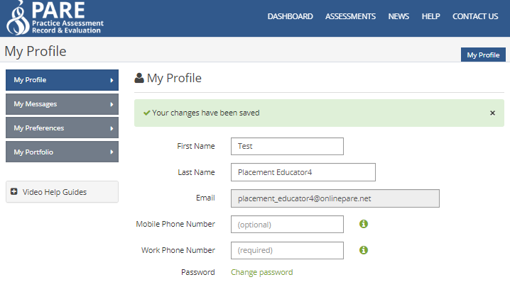
Name and Contact Details

Change Password Link

Under the contact details section, you will see the profession list, for you to add or amend your selected professions, as applicable. The profession(s) selected, will restrict your access to the learner documentation and notifications on PARE, to those that are applicable for your profession(s). If your selected profession(s) includes a nursing profession (Nursing, Midwifery, Nursing Associate, SCPHN Nursing and District Nursing), you will also see a declarations section on your PARE profile (otherwise you can skip the next section). When you have reviewed your PARE profile, and updated if required, you will then be ready to explore your PARE Dashboard.

Nursing & Midwifery Council Declarations
If your selected profession(s) includes a nursing profession (Nursing, Midwifery, Nursing Associate, SCPHN Nursing and District Nursing), then your PARE profile screen will display the following section for the management of your NMC declarations.

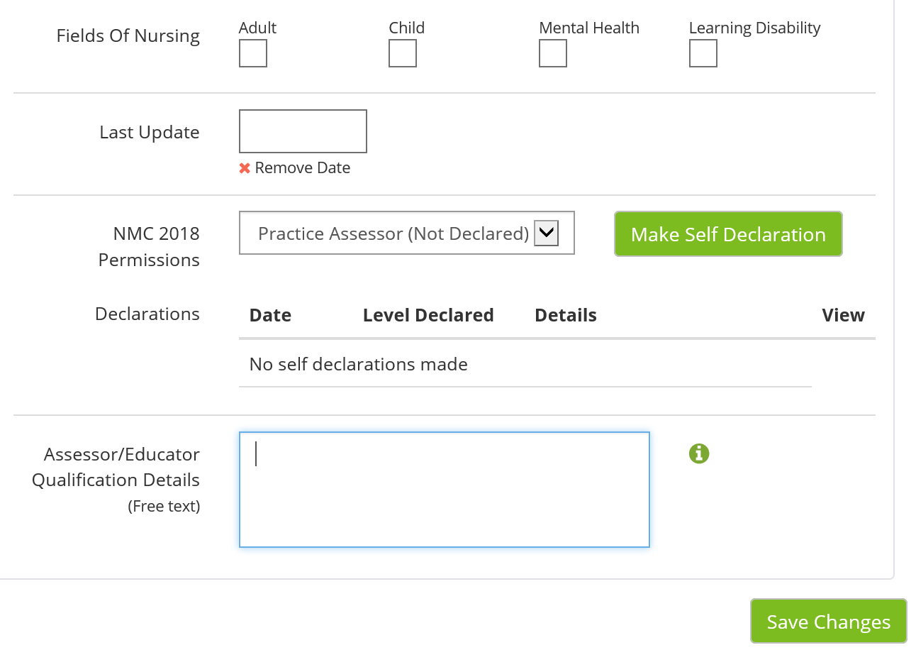
Add in the date of your latest update
Input the training you undertook to become a Practice Assessor/Supervisor.
Click save
Click here to make a self-declaration

NB: Any information you add to a data entry screen on PARE has to be saved by clicking on the ‘Save’ button. Be sure to click the ‘Save’ button before you leave the screen or you could lose your additions.

The additional nursing profession items on the My Profile screen include the Fields of Nursing (Adult, Child, Mental Health, and Learning Disability), for selection of one of these, as applicable.

The 2018 NMC Declarations Section enables nursing professionals to specify their 2018 NMC Permission level, whether this is Practice Supervisor (the default), or Practice Assessor. PARE supports both ‘self-declaration’, for a placement educator to be able to complete their own self-declaration in their PARE profile, or for a Placement Senior Admin to ‘declare’ the permission level for their placement educators. The approach taken will depend on the organisation. Some organisations may conduct Practice Supervisor/Assessor workshops,and update their staff profiles on completion of one of these. It is advisable to check with your Placement Educator Lead/Placement Senior Admin first.

If you are self-declaring your 2018 NMC permission level, then on selecting the required level, and clicking the Save button, you will be able to complete the corresponding NMC self-declaration by clicking on the ‘Make Self-Declaration’ button. This opens up the appropriate online version of the NMC self-assessment form (all of which can be viewed, along with other resource material, via the Governance link at the top of the PARE website – see next section).

See top section of the online Practice Assessor Self-Declaration form below:

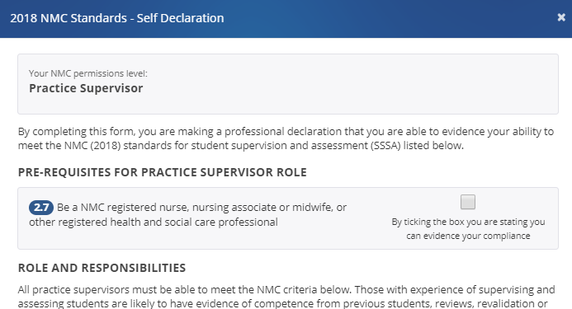
Tick all required checkboxes on Self-Declaration form

At the bottom of the self-declaration form, click on the green ‘Add Signature’ button to electronically ‘sign’ the form (PARE stores your login credentials as signatory to the form)

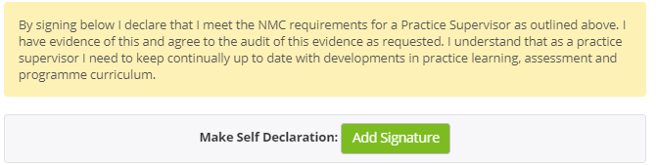
Self-Declaration Add Signature Button to sign and submit form

This submits the information to the system and you will see the declaration details, including the declaration date, level declared, and whether self-declared or declared by a Placement Senior Admin. A View button (document icon) is also displayed, for opening the declaration form to view and download as a PDF if required. You will also have the option to delete the declaration if incorrectly

declared:

Remove Declaration Button

Declaration Details

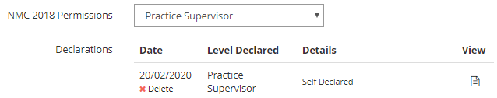
View Self-Declaration Form / Download PDF

A declaration added by a Placement Senior Admin will include the Placement Senior Admin name details, and the record will show as non-accessible (greyed out):
Placement Senior Admin Declaration Details
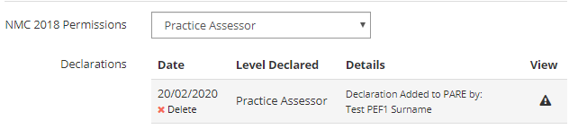
When you have reviewed your PARE profile, and updated if required, you will then be ready to explore your PARE Dashboard.

The PARE Dashboard
When you log in to your online PARE account, you will be presented with the ‘Dashboard’ area of the site. From your PARE Dashboard you will be able to navigate to other areas of the website, and return back to the Dashboard at any time. The Dashboard contains certain key sections and links to many features. The following screenshots of the top half and bottom sections of the PARE Dashboard demonstrate the features and links, and are followed by a more detailed description of the main features.

Please note that, depending on your PARE account setup, and whether or not learner documentation has been assigned to you on PARE, your PARE Dashboard may not display all the sections shown in the screenshots (specifically the PAR Documents and Learner Timesheets sections).

Dashboard Top Section
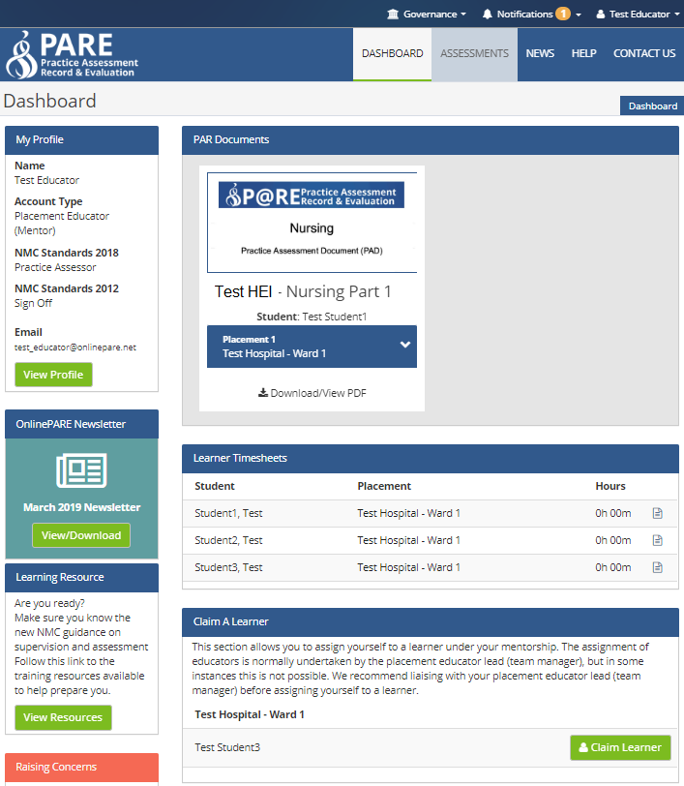
Resource Materials Notifications

Account ID – Log In / Out

Home Page Link

Main account details

PARE Screen Navigation

Your Learner PAR Documents
(N/A)

View account Profile

PARE News-letter

NMC Standards -Resources
Learner Timesheets
(N/A)

Claim a Learner
(N/A)
View Profile: Click on this button to view and update your PARE account details, including your applicable PARE profession(s), and your mentorship qualifications details including the 2018 NMC practice supervisor and assessor declarations for the nursing professions. You can also access your account details, including your PARE profile, via your account ID link at the top right corner of the website.

Notifications: Click on this link to access any messages the system has sent to your account. See later section on Notifications, for further details. You can set preferences as to how often you receive reminderemails that you have unread notifications, via the View Profile button on the Dashboard, and selecting the ‘My Preferences’ (or via your account ID link at the top of the website).

PARE Screen Navigation: Click on these screen navigation items to navigate between the main PARE screens; primarily the Assessments (where applicable) and Dashboard screens, and to access the PARE newsfeed, Help, and PARE contact details screens.

Account ID - Log In/Out: Click on your user account ID at the top right of the website, to log in and out of the website, and to access your account details when logged in. Via this link you can access your PARE profile (My Profile) and notifications (My Messages), setup preferences regarding how often you wish to receive notifications (My Preferences), and access your PARE portfolio (My Portfolio).

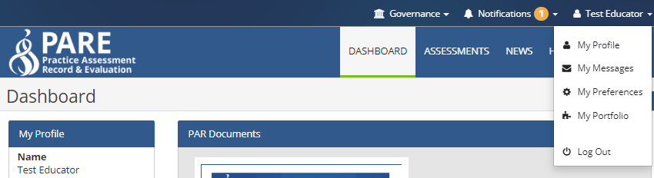
Account ID -Log In / Out

Dashboard Bottom Section

Your Placement Areas: This section lists the placement area(s) to which you have been assigned on PARE. It is important to check if your placement area details are correct. Please contact your Placement Educator Lead/Placement Senior Admin if the placement area details are not correct, or you need to be assigned to a placement area. Click on the Placement Educator Leads button (document icon) or the ‘View Placement Senior Admins’ button to view their names and emails addresses.

View Demo Links: Click on this link to open a pop-up window with a list of demo documents that are available for you to view and to familiarise yourself with, before a learner arrives on placement with you.

Pare Access Levels: Click on this link to view a description of the different PARE account access levels, including the features available for each type of account. If you are considering an account upgrade, to enable you to manage other PARE users and learner assignments for your placement area for example, you will need to liaise with your Placement Educator Lead/Placement Senior Admin. It is an important feature of PARE, for the efficient operation of PARE placement administration, for all placement areas to have at least one, currently active, Placement Educator Lead.

PARE Newsfeed Items: This section lists news releases by the PARE team, including information regarding new features on PARE, and news items from across the PARE community.

Useful Downloads: This section contains useful downloads documentation.

Notifications
Next time you log on to PARE, you will also see an indicator against the Notifications link on the top bar of the web site, informing you that you have unread notifications. If you click on this link, you can access the ‘My Messages’ screen, for viewing and managing all your system notifications. The same screen can also be accessed via the View Profile button on your PARE Dashboard. My Messages displays all your system-generated notifications, with an indication of those that have been read (green tick) and those that remain unread (red cross).

For all notifications that remain unread in your My Messages screen, you will receive reminder notifications. You can adjust the frequency that these are sent out, in the My Preferences screen, from the default two email notifications per week, to daily, weekly, or never send. This last option is only recommended if you are not going to be supervising learners for a while; otherwise notifications remain an integral part of keeping you up-to-date with important communications regarding your learner(s).

Once your account is activated and you have reviewed your PARE profile, explored your PARE Dashboard and read any notifications, you are ready to use the PARE system.

The PARE team always welcomes feedback on the features provided by online PARE. New features are being added all the time, in response to feedback and requests from the PARE community of users. Please keep an eye on the PARE newsfeed for further information on new feature releases.

The PARE team are available to advise on any technical issues you may have (please see the PARE team contact details at the end of this Guide).

Evaluations
On completion of a learner’s placement with the supervising team, learners will receive PARE notifications from PARE reminding them that their evaluation is due for completion and submission (in some regions the evaluations are known as NET Surveys). The evaluations become unavailable for the learner to complete, in most cases, two weeks after the placement end date. This is to ensure that the evaluation feedback is as close to the evaluation experience as possible, and the feedback does not become skewed with the passing of time.

Placement evaluations are an integral part of PARE, as learner feedback provides the central core of the placement quality management process. Learners can also be very disappointed to discover that their evaluations can no longer be submitted, once the deadline has passed, and they are then unable to download the associated PARE completion certificate (although the certificate is not a course requirement).

It is recommended that learners are reminded and encouraged to complete their evaluation towards the endoftheirplacement, and to be open, honest and to act with integrity when submitting anything to the system. Placement Educators need not be present for learners to complete the practice learning evaluation, but providing learners the opportunity in placement time is likely to aid compliance. Outcomes of actions raised by Placement Educator Leads/Placement Senior Admin in response to learner feedback may be communicated back to the learners if this option is selected by the author of an evaluation action plan.
All evaluation, whether positive or highlighting areas of development are valuable, and assist the organisation in reporting student placement experiences to Health Education England.

FAQs & Further Help
Your Placement Educator Lead/Placement Senior Admin will be able to advise you on learner and placement educator support issues. If you are unsure who your Placement Educator Lead(s) or Placement Senior Admin are, within your organisation, then the ‘My Placement Areas’ section of your PARE Dashboard will contain the PARE email addresses for any Placement Educator Lead/Placement Senior Admin users for your placement areas.

In addition, the PARE website has a FAQ section, as well as videos and training resources. See the following links:
- Complete PARE Placement Educator user guide (contains elements that are not used in Leeds) https://onlinepare.net/files/guides/PARE.Placement.Educator.Guide.v1.1.pdf
- Complete PARE Placement Educator Lead user guide https://onlinepare.net/files/guides/PARE.Placement.Educator.Lead.Guide.v1.1.pdf
Frequently Asked Questions (FAQ) resource: http://demo.onlinepare.net/faqs.php Training Demo videos: http://demo.onlinepare.net/training-resources.php

The PARE Team
The PARE team, based at the University of Chester, are available to advise on any technical issues in your use of PARE. Please note that the PARE team cannot advise on specific student issues. This should be addressed in the usual manner using the usual support networks (Placement Educator Lead/Placement Senior Admin, learner’s Academic Assessor.

Please email your issue details to the PARE team, from the same email address that is your PARE account email address, making sure to include all the details the team will need to investigate and resolve your issue. For more urgent enquiries, you can contact the PARE technical helpline (see number below), which is available Mon-Thu: 8.30 – 17.00, Fri: 8.30 – 16.00:

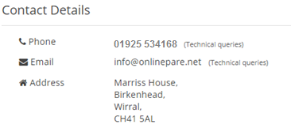

PARE -FAQs

What is PARE?
The online, cloud-based platform accessed by students, Universities and staff from all clinical placement areas across all professions.

What Is PARE used for?
In Leeds we use PARE to:
- keep a record all clinical placements, which students can access for useful information prior to starting placement
- record the training Practice Assessors/Practice Supervisors/Practice Educators have undertaken in order to meet the NMC/HCPC requirements to be suitably prepared to support students
- You need a PARE profile to be given access to your students PAD (Practice Assessment document)
- record educational audits
- invite students to leave evaluations of placements

Do we use PARE for assessment?
Not currently. This function is available on the website but currently in Leeds we use Pebble PAD to record Nursing assessments and bespoke on line platforms for AHP’s. Some of our AHPs are moving to PARE-based assessment documentation in the 21/22 academic year - communication will follow.
Nurses will be sent a login for Pebble PAD when their student grants them access.

Who creates my account?
Once you have completed relevant training, the person with Education Lead PARE access to your placement area, can create your account.

Where is my activation email?
Once your profile is created an email is auto-generated - it may have gone to your Junk mailbox.

What is my username?
This is your registered email address.

I have forgotten my password, how do I recover it?
On the sign in tab, click ‘forgot password’’. A link will be sent to your email address. PARE - Key Functionality Guide - YouTube
To change an existing password, when logged in click on ‘view profile’ where there is an option to change password.

Can PARE be accessed from devices?
Yes, you can access the website from any internet enabled device, including smart phones, tablets, laptops and desktops. If your organisation has a firewall blocking access to the site contact PARE: info@onlinepare.net

Is the website secure?
The PARE website is highly secure, using industry-leading technology to keep data safe. It is hosted on UKFast - a server managed and operated in an ISO-accredited data centre located in Manchester.

I am a Practice Assessor/Supervisor/Educator. What do I need to do on PARE?
- Activate your account (the initial email may be in your Junk folder)
- Make a self-declaration to record the training you have undertaken in order to support students
- Complete then record your Practice Assessor/Supervisor/Educator updates
- Ensure your email address is correct - this is essential so that students can share their PAD with you

I am an Education Lead for my placement area. What do I need to do on PARE?
- Ensure your individual profile is up to date and if you are an NMC/HCPC registrant, make a self-declaration
- Maintain the clinical placement profile. This can be edited as required should changes occur within the service. Students appreciate this overview of the placement once it is allocated to them.
- Read student evaluations and provide feedback to the team as they do not have access to these. You may want to create action plans in response to aspects of evaluations. Your PLF can support you in this.
- Take part in the Educational Audit when contacted by the liaison lecturer/PLF. This is recorded on PARE.

What if I move to a new clinical area?
If it is in the same organisation, the Education Lead in the area you leave can ‘revoke access’ to their placement profile and the Ed Lead in the new area can search the educator register and add you to their placement profile.
If you move organisations you will need to email PARE so they can move your profile. info@onlinepare.net

Where can I access support?
- PPU website contains resources including a video and ‘how to’ guides for the functions of PARE we use in Leeds [LINK to PARE resources page]
- The PARE website has user guides and videos guides throughout the website. The following guides are from the PARE website (caution - they contain instructions on using functions of PARE we do not currently use in Leeds)
  - https://onlinepare.net/files/guides/PARE.Placement.Educator.Lead.Guide.v1.1.pdf
  - https://onlinepare.net/files/guides/PARE.Placement.Educator.Guide.v1.1.pdf
- For technical support, you can contact PARE on info@onlinepare.net
- Your Practice Learning Facilitator (PLF) or Learning and Development team for your organisation can provide support - email the contact for your organisation:-
-Leeds Community Health hayley.ingleson@nhs.net
-Leeds Primary Care leedsprimarycare.wth@nhs.net
-Leeds Teaching Hospitals leedsth-tr.practicelearningfacilitator@nhs.net
-Leeds and York Partnership NHS Foundation Trust pldt.lypft@nhs.net
-All others (Private/Independent/Voluntary organisations and other NHS services) leedsth-tr.pivoplfteam@nhs.net
PebblePAD -Nursing Practice Assessment Document

All students across West Yorkshire and the Humber are now u sing electronic Practice Assessment Documents.

The hexagons display the contents of the PAD.

It replaces the paper booklets you may have previously seen and used yourself.

Your student will share their PAD with you by searching for your email address. You need to have a PARE account for them to be able to do this successfully. You will be sent login details from epad@leeds.ac.uk who you can email with any issues you may have.

There are video guides and document guides available online to assist you with completing it and the students themselves are valuable sources of support in this!
How to assess my student using ePAD video-https://mymedia.leeds.ac.uk/Mediasite/Play/2a56fc34e16448bdbf2545f53e5361b51d
User guides and useful information on the PAD
https://practiceplacements.leeds.ac.uk/nursing-and-midwifery/information/electronic-practice-assessment-documents-epad/
Excellent website for SSSA resources & PAD resources for our Region and beyond:
https://myeweb.ac.uk/mye-pad/
We aim to arrange training on using the PAD and will send out invites when dates are available.

