**ORDERPLUS SYSTEM – Place an order**

1. **Login**

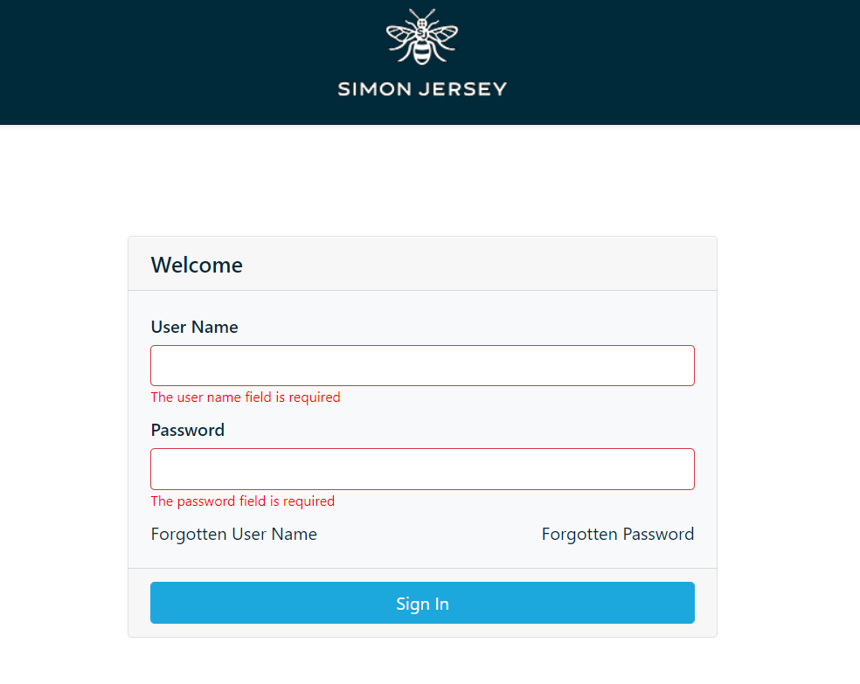

1. **Order – select ‘orders’**



1. **New order**

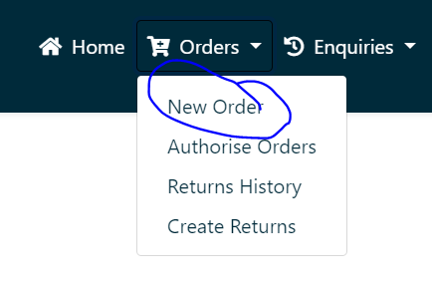

1. **Select your order**

Select each item in turn and add your **full** allocation (**2x Epaulettes, 3x Trousers, 3x Tunics**) to your basket.

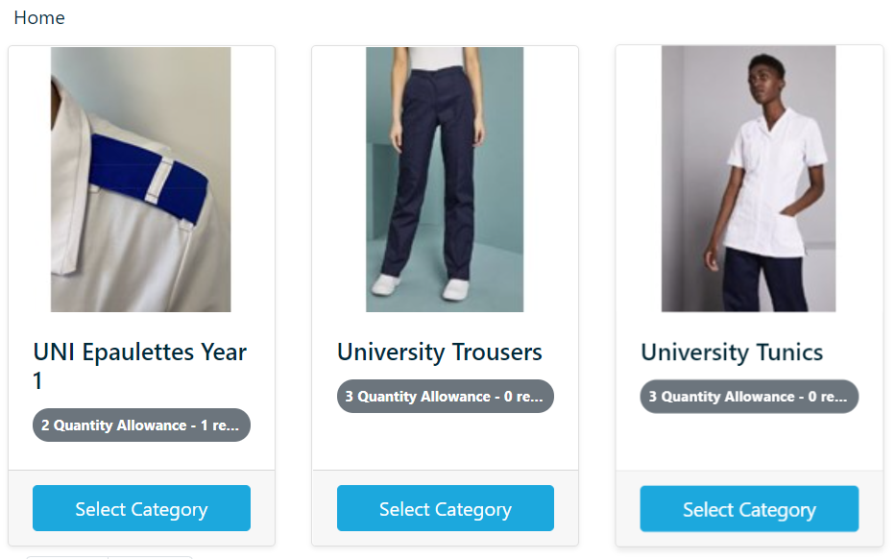

--

1. **Select female / male trousers and tunics**

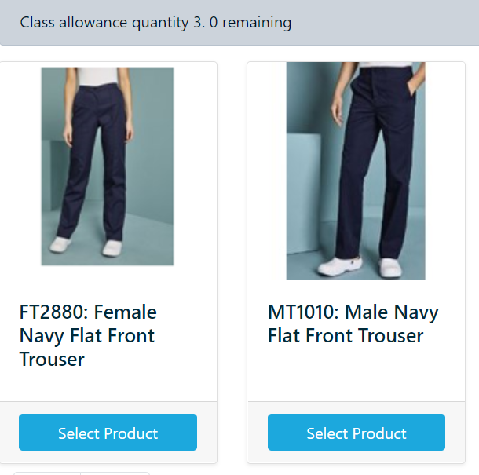

1. **Select size and quantity (ignore all other fields)**

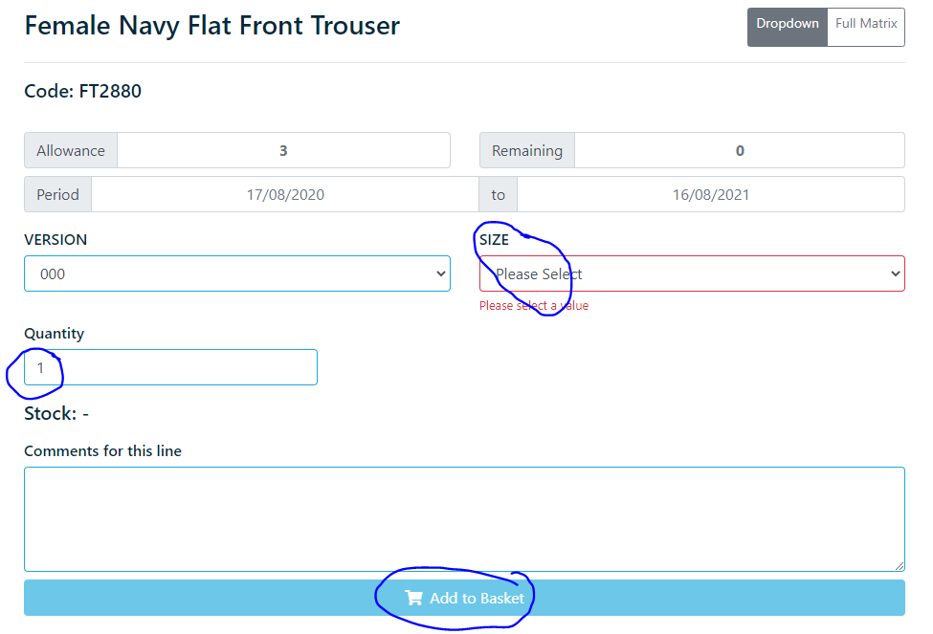

Select your full allowance:

Epaulettes – **2 sets**

Trousers – **3**

Tunics - **3**

1. **Repeat steps 4, 5 & 6 to add 2x Epaulettes, 3x trousers and 3x tunics to the basket**
2. **Checkout – you should have 8 items**

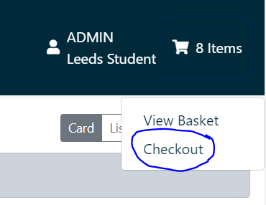

1. **Order details (ignore ‘additional charges’, ‘invoice details’ and ‘order lines’)**

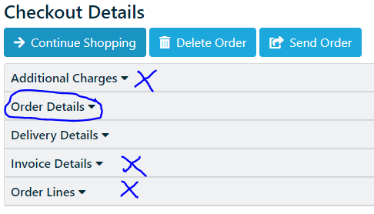

* 1. Type your first and surname (eg Jack Jones)
  2. Type your University email address
  3. Ignore all other fields

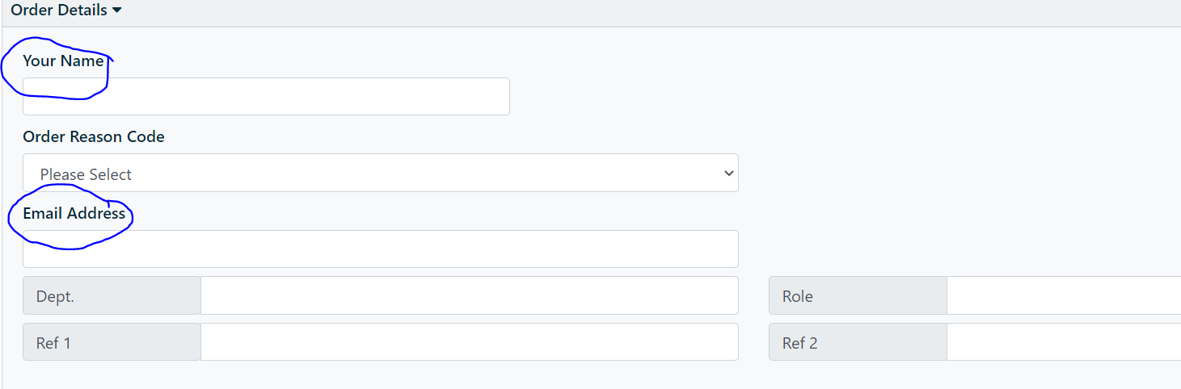

1. **Delivery details (ignore ‘additional charges’, ‘invoice details’ and ‘order lines’)**

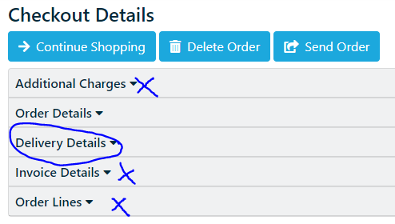

* 1. Select ‘Manual Delivery Address’
  2. Type your name in F.A.O
  3. Tick ‘enter address manually
  4. Type your TERM TIME address

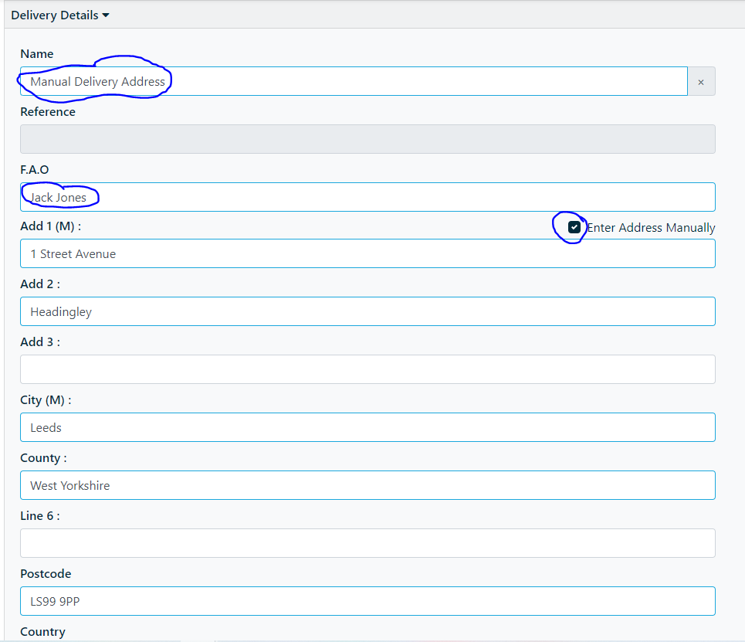

1. **Send order**

