Getting Started with PebblePad as a Practice Assessor / Supervisor

Getting Access
Your trainee will first need to choose to share their MYEPAD (Nursing) or eMORA (Midwifery) workbook with you as an external assessor by searching for your PebblePad account

If you don’t have an account yet or have forgotten your password, please go to ‘How to Request an Account/Forgotton Password’ below

Once a student has shared their workbook, you will then receive an email from PebblePad containing a link to access their work.
Clicking on the link should open your PebblePad dashboard page once you have logged in
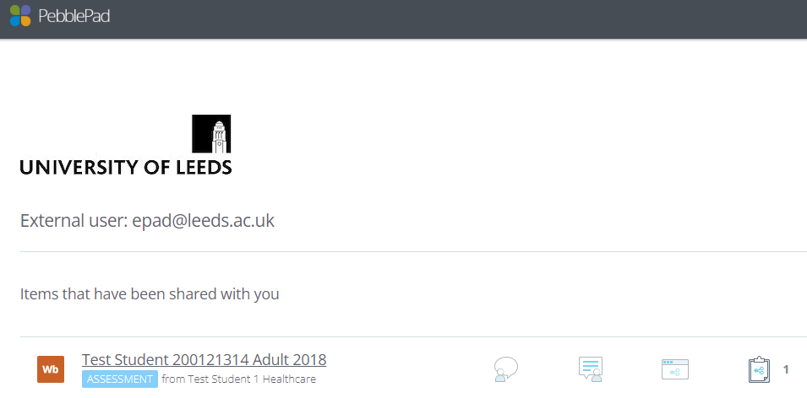

You should see the students workbook listed. Click on it to open it.

IMPORTANT: Ensure you click on the instance with the blue 'ASSESSMENT' label and the students name (if there is no blue Assessment label then the student has not shared their workbook with you correctly and you will not be able to edit it)
You can also access your PebblePad dashboard directly via https://v3.pebblepad.co.uk/login/leeds and selecting the option for ‘External Contributor/Assessor Account’ Your username is your NHS email address.

How to Request a PebblePad Account
If you have undertaken the relevant Practice Assessor or Practice Supervisor training you should contact the Practice Learning Facilitator at your Trust to ensure that they have created you a Practice Educator record on PARE .

You can then contact epad@leeds.ac.uk and we can create an account for you for the University of Leeds PebblePad installation (note: we are unable to create an account for other University’s instances, you will need to contact their PebblePad support teams separately – your trainee should be able to provide contact details if needed)

Forgotten Password
You can reset your password by going to the University of Leeds PebblePad Login screen here: https://v3.pebblepad.co.uk/login/leeds - click on the ‘External contributor / Assessor Account’ option. Your username is your email address. You can then select the Forgotten my Password option.
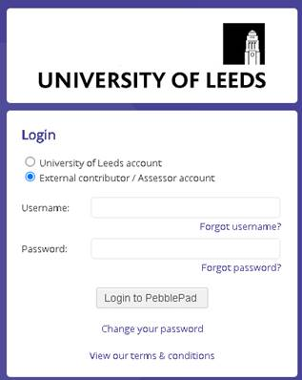
NOTE: Sometimes password reset emails don’t make it through Trust firewalls, please contact epad@leeds.ac.uk if you have any issues with the process

Please also refer to the PebblePad guidance for Assessors/Supervisors here for further information
